Title of the Extended Abstract
Extended Abstract
Purpose
Purpose Purpose Purpose Purpose Purpose Purpose Purpose Purpose Purpose Purpose Purpose Purpose Purpose Purpose
Theoretical framework
Theoretical framework Theoretical framework Theoretical framework Theoretical framework Theoretical framework Theoretical framework

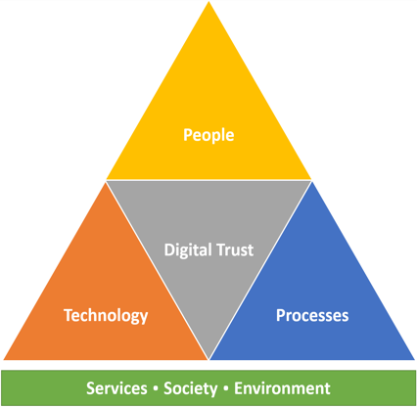

Figure 1 Intuition types and digital trust

Methodology
Methodology Methodology Methodology Methodology Methodology Methodology Methodology
Results
Results Results Results Results Results Results Results Results Results Results Results Results Results Results
Table 2 Results of Curve-Fitting Analysis Examining the Time Course of Fixations to the Target
Logistic parameter | 9-year-olds |  | 16-year-olds |  | t(40) | p | Cohen's d
 | M | SD | M | SD
Maximum asymptote | .843 | .135 | .877 | .082 | 0.951 | .347 | 0.302
Crossover | 759 | 87 | 694 | 42 | 2.877 | .006 | 0.840
Slope as change | .001 | .0002 | .002 | .0002 | 2.635 | .012 | 2.078

Discussion and conclusion
Discussion and conclusion Discussion and conclusion Discussion and conclusion Discussion and conclusion

Keywords: keyword, keyword, keyword

References
Jackson, L. M. (2019). The psychology of prejudice: From attitudes to social action (2nd ed.). American Psychological Association. https://doi.org/10.1037/0000168-000
Rogers, C. R. (1961). On becoming a person. Houghton Mifflin.
Grady, J. S., Her, M., Moreno, G., Perez, C., & Yelinek, J. (2019). Emotions in storybooks: A comparison of storybooks that represent ethnic and racial groups in the United States. Psychology of Popular Media Culture, 8(3), 207–217. https://doi.org/10.1037/ppm0000185

